MACH4METAL

metalworking machinery
Transito 21
6909 DA BABBERICH Netherlands
Tel. +31 (0)316-247123
Fax: +31 (0)316-247956
info@mach4metal.com
www.mach4metal.com

Bank No : 66.52.13.883
IBAN : NL33 INGB 0665 2138 83
BIC : INGBNL2A

ROUNDO plate roll 3000 x 40 mm

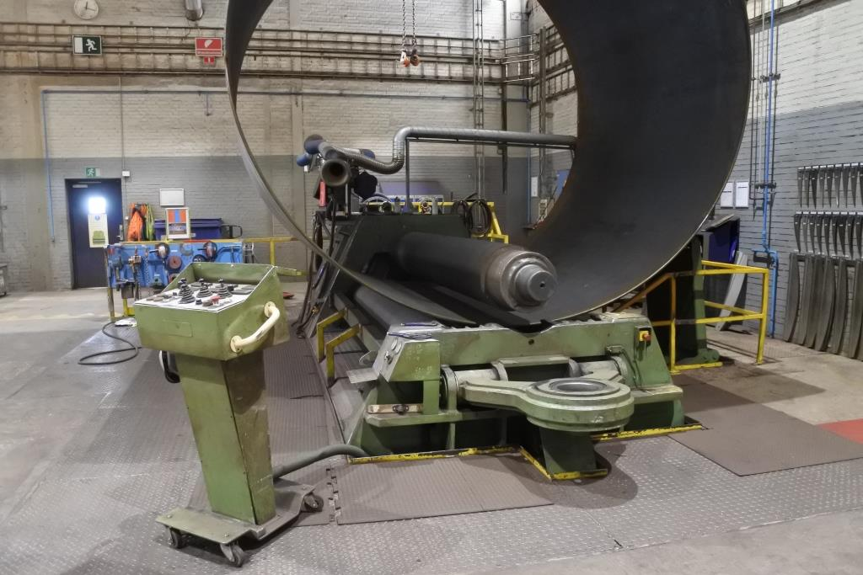
- Make : ROUNDO Sweden
- Typ : PAS 460
- Serial No :
- Age : 1995

- Number off rolls : 4 x
- Bending length : 4.000 mm

- Thickness by Ø 5000 : 40 mm
- Thickness by Ø 3000 : 37 mm
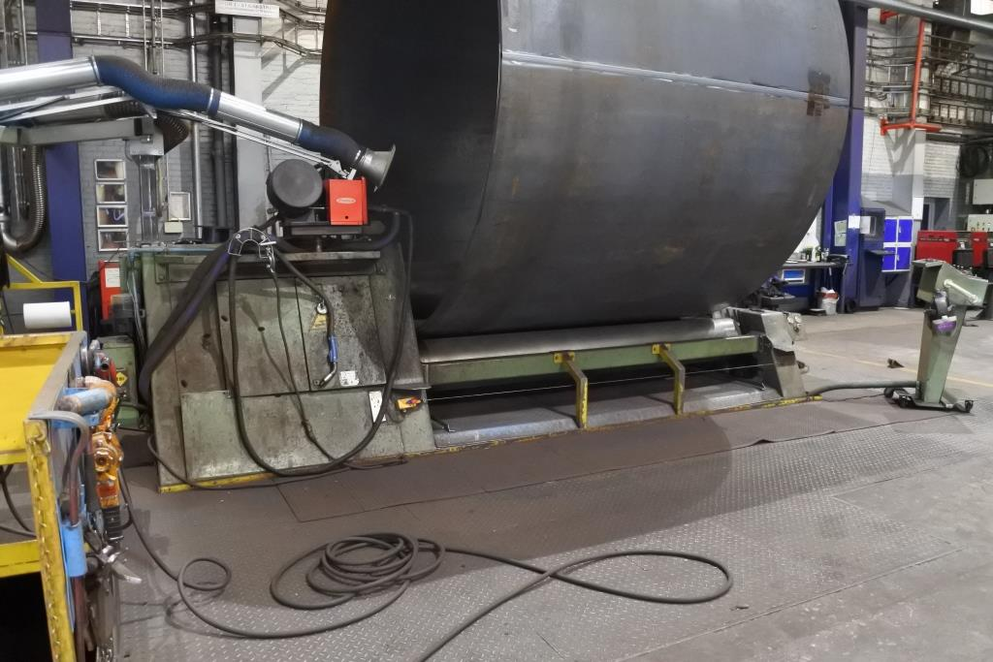
- Thickness by Ø 1400 : 30 mm
- Pre bend : 25 mm

- Top roll Ø : 460
- Side roll Ø : 390
- Power kW : 55

- Dimensions
- Length : 7.000
- Width : 2.800
- Height : 2.800
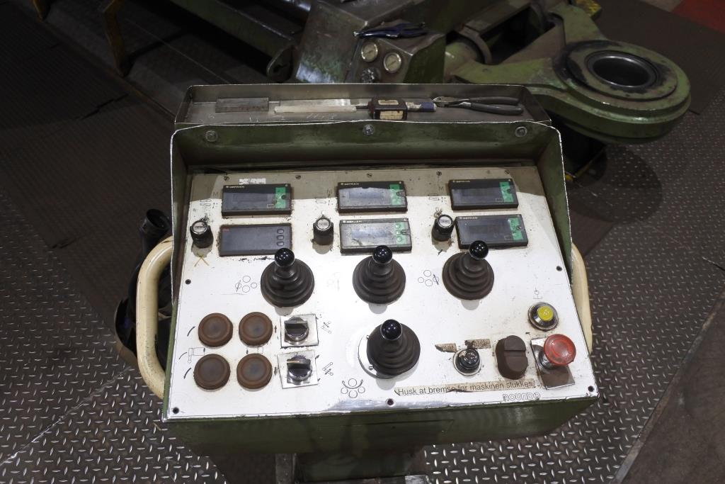
- Weight : 38.000

- Hydraulic driven
- Hydraulic drop end
- 4 roll plate bender

- Incl. remote control
- Incl. optical readout

Please Note: The above information has been obtained to the best of our ability and belief from, and from the manufacturers where possible. It is given in good faith, but its accuracy can not be guaranteed. Accordingly, it will not form a representation or constitute contractual terms. We advise you to check any vital details!

